CNSL Lab Assignment 14
Neeti Kurulkar
To study the IPsec (ESP and AH) protocol by capturing the packets using Wireshark tool.

- Authentication Header (AH) in IPv4
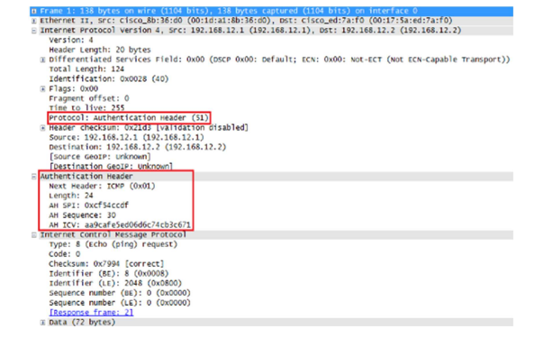

- Encapsulating Security Payload (ESP)
